S_ALR_87011990 -

Functionality
The asset history sheet is the most important and most comprehensive report for the year-end closing or for an interim financial statement. As with all other lists, it can be set up with any sort versions, and total on any group level. You can also create a compact totals list without individual asset information.

Scenario
You can freely define line and column structure in the asset history sheet (for more information, see the Implementation Guide). SAP delivers country-specific versions of the asset history sheet, which satisfy the legal requirements of the given country (for example, the 4th EC directive). Additional history sheet versions are also available (for example, for displaying the development of reserves for special depreciation).

Requirements
None

Menu Path | Accounting → Financial Accounting → Fixed Assets → Information System → Reports on Asset Accounting → Notes to Financial Statements → International → S_ALR_87011990 - Asset History Sheet
Transaction Code | S_ALR_87011990

1. Double Click on S_ALR_87011990 - Asset History Sheet
Asset History Sheet

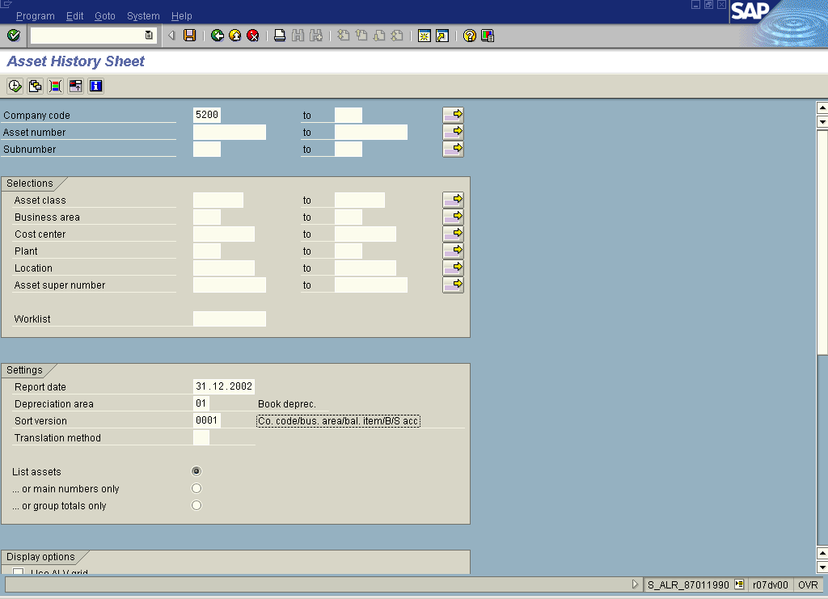
2. Update the following fields:

Field Name | Field Description | Values
Company code | The company code is an organizational unit within financial accounting. | Example: 5200
Report Date | The report date, on which the evaluation should take place. | Example: 31.12.2002

3. Click <radio button> List assets .
4. Click Execute .
Asset History Sheet

